Kliiniline küsimus nr 3

Kas patsiendi valu regulaarne hindamine ja dokumenteerimine vs mittehindamine alates preoperatiivsest perioodist parandab perioperatiivse ägeda valu ravi tulemust?
Tulemusnäitajad: valu tugevus, valu vähenemine, lisavaluvaigisti vajadus, patsiendi (eestkostja) rahulolu valuraviga

1. Valu hindamine ja dokumenteerimine

Ravijuhendid

Kokkuvõte ravijuhendites leiduvast.

1. Acute Pain Management: Scientific Evidence 2010 ( AU-10)
2. ” Behandlung acuter perioperativer und posttraumatischer Schmertzen ” 2009” ( DE-09)
3. Good practice in Postoperative and Procedural Pain Management (PEDI 12)

Ravijuhendites ei ole võrreldud valu hindamise alustamist vs mittealustamist preoperatiivses perioodis ja selle mõju postoperatiivsele valule lastel. PEDI-12 ravijuhendis rõhutatakse, et laste valu tuleb hinnata, sest efektiivne valu hindamine aitab ennetada postoperatiivset ägedat valu. Kõigis ravijuhendites on rõhutatud, et postoperatiivset ja protseduuri valu saab hinnata igas vanuses lastel, hindamine peab olema regulaarne ning valu hindamiseks tuleb kasutada erinevas vanuses lastele sobivaid valuskaalasid. Samuti on lisatud, et valu tugevus peab olema dokumenteeritud kui „viies eluline näitaja“. Ainult järjekindel dokumenteerimine tagab multiprofessionaalse meeskonna kõikide liikmete piisava informeerituse ja võimaldab seeläbi valuravi juhtida. Eeltoodud ravijuhenidites tõdetakse, et laste postoperatiivne valu hindamine on tihti ebaregulaarne.

PEDI 12

Children’s pain should be assessed. Effective pain assessment is essential both in terms of its contribution to the prevention and relief of a child’s pain and also in its role as a diagnostic aid. The centrality of pain assessment to high-quality pain management is enshrined in many current pain management recommendations, position statements, reports, and guidelines Good pain assessment contributes to the preventionand/or early recognition of pain as well as the effective management of pain.

Süstemaatilised ülevaated ja muud uuringud
Kokkuvõte
Vaatamata erinevatele otsingusõnadele (regular perioperative pain assessment/ pain evaluation, perioperative pain measurement, pain scoring, pain measurement, perioperative pain, postoperative pain measurement, postoperative complications, perioperative pain measurement/assessment and documentation, perioperative pain management otsingusõnadele lisati laste filter neonate, infant, children, adolescent) ja nende kombineerimisele ei leitud täpselt kolmandale kliinilisele küsimusele vastavaid teemakohaseid süstemaatilisi ülevaateid. Leidus üks süstemaatiline ülevaade, mille tulemustest selgus, et suurel osal lastest ei mõõdetud 24 tunni jooksul postoperatiivset valu. Samuti tõdeti, et õdede poolne valu hindamine ja juhtimine ei ole kooskõlas avaldatud juhenditega. (Twycross, A., et al. (2015). Lisaks on mitmetes õdedele mõeldud uurimistöödes jõutud järeldusele, et valu hindamine ja dokumenteerimine lastel on ebaregulaarne. (Shrestha-Ranjit jt. (2010), Taylor jt. (2008), Twycross, A. (2007). Regulaarne valu hindamine ja mõõtmine võib parandada valu juhtimist ja tõsta patsiendi, lapsevanemate ja personali rahulolu. Valuravimite valik otsustakse peale esmast valu hindamist. Peale valuvaigistite manustamist tuleks teha ümberhindamine, et kontrollida sekkumise efektiivsust

Süstemaatiline ülevaade

- Twycross, A., et al. (2015) „Paediatric nurses’ postoperative pain management practices in hospital based non-critical care settings: A narrative review“ International Journal of Nursing Studies 52 (2015) 836–863

Objectives: To investigate paediatric nurses’ postoperative pain management practices with the aim of identifying the factors associated with undermanaged paediatric postoperative pain. Design: Systematic search and review. Data sources: PsychInfo, CINAHL, PubMed, EMBASE and hand searching. Review methods: English peer-reviewed quantitative, qualitative, or mixed methods research articles published between 1990 and 2012 exploring registered nurses’ paediatric postoperative pain management practices were included. Articles with a primary focus on nurses’ pain management practices in the neonatal or paediatric intensive care units, recovery room, and/or focused on children with cognitive impairment were excluded. The search terms used were: postoperative pain; nurs*; paediatrics; pediatrics; children; pain assessment; non-pharm*; analges*. Titles and abstracts were used for initial screening. Two researchers conducted data extraction and assessment of rigour for each paper. Results: From the initial 248 citations, 27 studies were included. Most studies were descriptive and examined relationships between personal factors and nurses’ pain management practices. Observational data from four papers added insights beyond that provided in self-report studies. Two articles used experimental designs with vignettes. Data were categorised into four topics: pain assessment; pharmacological practices; non-pharmacological practices; and factors affecting practices. Despite improvements in analgesic administration over the past 20 years, practices remain suboptimal. Children’s behaviour appears to influence nurses’ pain assessment more than validated measures. A significant proportion of children did not have pain scores recorded in the first 24-h postoperatively. Children receive more analgesia when ordered around the clock compared to as required. However, around the clock analgesia prescription did not guarantee administration. Nurses reported using several non-pharmacological strategies routinely but some are not evidence based. Conclusions: The results of this review indicate nurses’ assessment and management of children’s pain is not consistent with published guidelines. Results of studies exploring nurse and child related factors are inconclusive. Research needs to examine the impact of organisational factors on nurses’ pain care practices. Intervention studies are needed to determine the most effective strategies to support and improve nurses’ pain care for children.

Muud uuringud
- Walter-Nicolet E., et al (2010). „Pain management in newborns: from prevention to treatment.“ Pediatric Drugs. 12:353-65

All neonates in the Neonatal Intensive Care Unit (NICU) or during the first days of life undergo painful and stressful procedures. Epidemiologic studies have shown that pain induced by these procedures is not effectively prevented or is inadequately treated. Pain experienced during the neonatal period may lead to negative outcomes, especially in preterm neonates. Prevention is the first step of pain management, and practical guidelines should be used in the NICU. Assessment must be done with adequate tools that take into account the infant's pathology and gestational age. Distinguishing between acute and prolonged pain is important for both assessment and treatment. The most common drugs that have been studied for the treatment of pain and stress are opioids, hypnosedatives, and NMDA receptor antagonists. Morphine and fentanyl are most frequently used for acute or prolonged pain in the NICU. They have potent analgesic effects and few immediate or long-term adverse effects. Midazolam is a commonly used hypnosedative, but its adverse effects limit its use. Drugs such as propofol and ketamine have been used for acute painful procedures; however, further research is needed to assess their long-term effects. Use of non-pharmacologic pain management techniques has increased in recent years. These methods are easy, inexpensive, and effective in helping newborns recover from painful procedures. Sweet solutions and non-nutritive sucking, breastfeeding, skin-to-skin mother care, swaddling, and facilitated tucking are the most commonly employed and evaluated non-pharmacologic methods. Hospitals should promote and improve parent involvement in pain management. In-service education and well organized hospital teams are crucial for successful implementation of pain protocols in newborns.

- Shrestha-Ranjit, J.M.et al. (2010) „Pain assessment and management practices in children following surgery of the lower limb“ Journal of Clinical Nursing, 19, 118–128

Aims. To examine paediatric nurses’ pain assessment and management practices in relation to postoperative care for children following surgery of a fractured lower limb and to compare these practices with evidence-based guidelines.
Background. Managing pain is one of the most challenging issues in current paediatric practice. The incidence of lower limb fractures is high in children, which often leads to pain and related complications in the postoperative period.
Design. A retrospective clinical audit study.
Methods. A retrospective audit of all medical records (n = 106) was undertaken over two years of children aged 5–15 years who were admitted for surgical procedure for a fractured lower limb. An audit tool was developed to collect data related to children’s postoperative pain assessment and management on the day of operation to the third postoperative day. The study was undertaken in a tertiary paediatric hospital in Australia.
Results. The retrospective audit revealed that assessment and management of children’s postoperative pain was inadequate. On average, 75% of children experienced some degree of pain; 50% had moderate to severe pain. Nurses assessed pain less frequently compared to the number of times they were expected to assess pain postoperatively. Most analgesics were prescribed on an ‘as needed’ basis and patients received significantly lower amounts of analgesics than prescribed amounts.
Conclusion. The clinical audit revealed that addressing children’s postoperative analgesic needs was not consistent with evidence-based guidelines. Relevance to clinical practice. While this study was undertaken in only one hospital, the results are likely to be applicable to
other children’s hospital settings. Nurses need to be proactive in promoting effective assessment and management of pain in children. The results of this study provide a useful guide for planning and implementing future strategies to improve postoperative.

- Simons, J., et al. (2009). „Influences on nurses’ scoring of children’s post-operative pain“. Journal of Child Health Care. 13(2) 101–115

Abstract
There is a lack of clarity as to why some nurses are not delivering optimal pain management to children post-operatively. This retrospective chart review study examined nurses’ pain scoring on 175 children during the first 24 hours post-operatively. Data were analysed on the amount of assessments made, assessment scores recorded, as well as the age, gender and type of surgery performed. One-quarter of children had no assessment record of their pain in the first 24 hours post-operatively. When the pain tool was part of an observation chart, nurses recorded more pain scores. Nurses’ scoring of children’s pain is influenced positively by children under five years of age and those who undergo abdominal surgery. Nurses who had access to one document for recording vital signs as well as pain scores were more likely to assess and record a child’s pain score than nurses who had to use a separate chart.

- Taylor, E.M, et al. (2008) „Pain in hospitalized children: a prospective cross-sectional survey of pain prevalence, intensity, assessment and management in a Canadian pediatric teaching hospital.“ Pain Res Manag. 13: 25-32.
BACKGROUND: Pain is under-recognised and undertreated. Although standards now exist for pain management, it is not known if this has improved care of hospitalized children.
OBJECTIVES: To benchmark pain prevalence, pain intensity, pain assessment documentation and pharmacological treatment of pain. The aim was to highlight areas of good practice, identify areas for improvement and inform development of hospital standards, education,
future audits and the research agenda.
METHODS: The present prospective cross-sectional survey of all Medial and surgical inpatient units took place on a single day at the Hospital for Sick Children (Toronto, Ontario), a Canadian tertiary and quaternary pediatric hospital. A structured, verbally administered questionnaire was used to obtain information on patient demographics, pain before admission, pain intensity during admission and pain treatment. Charts were reviewed to establish frequency of documented pain assessment, the pain assessment tool used and analgesics given. Subgroup analysis was included for age, sex, visible minority or fluency in English, medical versus surgical services and acute pain service input.
RESULTS AND CONCLUSIONS: Two hundred forty-one (83%) of the 290 inpatients or their carergivers were interviewed. It was found that 27% of patients usually had pain before admission, and 77% experienced pain during admission. Of these, 23% had moderate or severe pain at interview and 64% had moderate or severe pain sometime in the previous 24 h. Analgesics were largely intermittent and single-agent, although 90% of patients found these helpful. Fifty-eight per cent of those with pain received analgesics in the preceding 24 h but only 25% received regular analgesia. Only 27% of children had any pain score documented in the preceding 24 h. It was concluded that pain was infrequently assessed, yet occurred commonly across all age groups and services and was often moderate or severe. Although effective, analgesic therapy was largely single-agent and intermittent. Widespread dissemination of results to all professional groups has resulted in the development of a continuous quality assurance program for pain at the Hospital for Sick Children. A re-audit is planned to evaluate changes resulting from the new comprehensive pain strategies.

- Twycross, A. (2007) “Children’s nurses’ post-operative pain management practices: An observational study“ International Journal of Nursing Studies 44:869–881

Background: Children continue to experience unrelieved moderate to severe pain post-operatively despite the evidence to guide practice being readily available. Previous studies have relied on self-report measures; there is a need to establish exactly how nurses manage children’s pain in practice.
Objectives: To ascertain how nurses actually manage post-operative pain in children and whether pain management practices adhere to current best practice guidelines.
Design: An observational study was carried out. Structured and unstructured data were collected.
Setting: A children’s surgical ward in the English Midlands caring for children from birth to 16 years.
Participants: Registered nurses (n ¼ 13) took part in the study.
Methods: Each participant was observed continuously for a period of 5 hours per shift for two to four shifts each. The role of the observer as participant was adopted whereby the researcher could shadow the nurse and act primarily as an observer. Data were collected for 36 shifts (185 hours).
Results: While nurses administered analgesic drugs when a child complained of pain, in most other areas practices did not conform to current recommendations and are in need of improvement. Nurses did not, for example, routinely assess a child’s pain, nor use non-drug methods of pain relief on a regular basis.
Conclusions: The sub-optimal pain management practices may be attributable to several factors. The professional culture of nursing and/or ward culture may result in poor pain management practices being perpetuated. Nurses may not have the requisite theoretical knowledge to manage pain effectively. A lack of priority may also be attributed to pain management. These areas need exploring further.

2. Valuskaalad

Ravijuhendid

Kokkuvõte ravijuhendites leiduvast.

1. Acute Pain Management: Scientific Evidence 2010 ( AU-10)
2. ” Behandlung acuter perioperativer und posttraumatischer Schmertzen ” 2009” ( DE-09)
3. Good practice in Postoperative and Procedural Pain Management (PEDI 12)
Ravijuhendites antakse soovitused, milliseid valuskaalasid postoperatiivse valu hindamiseks ja dokumenteerimiseks lastel võiks kasutada.

Vastsündinute postoperatiivse valu hindamiseks soovitavad nii AU-10 kui PEDI-12 kasutada käitumuslikke mõõdikuid (Observational/behavioral measures) PIPP ja CRIES, ning PEDI-12 ravijuhend lisaks veel COMFORT skaalat.

Imikutel ja kuni kolme aastastel lastel soovitatakse kasutada FLACC ja COMFORT skaalat (AU-10, PEDI-12).

Lastel (üle viie eluaasta) soovitavad mõlemad ravijuhendid enesehindamise skaalasid (Self-report tools), FACES (3-18 aastased), FPS-R (4-12 aastased), VAS ja NRS (alates 8 eluaastast).

PEDI-12

- No individual measure can be broadly recommended for pain assessment across all children or all contexts: Grade B
- Children’s self-report of their pain, is the preferred approach, where feasible: Grade B
- An observational measure should be used in conjunction with self-report with 3–5 year olds as there is limited evidence for the reliability and validity of self-report measures of pain intensity in this age group: Grade B
- Sole use of physiological measures in clinical practice is unproven and therefore not recommended: Grade D

AU-10

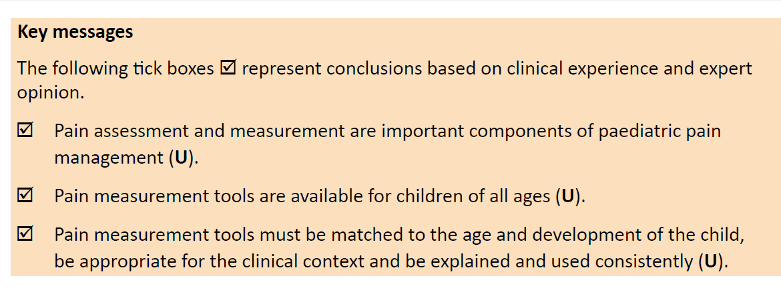

DE-09

- Valu tugevust tuleb regulaarselt hinnata lihtsa ühemõõtmelise valu tugevuse skaala abil. Soovituse tase A.
- Patsient hindab valu ise. Soovituse tase A.
- Valu tuleb hinnata kõikide valulike protseduuride ja ravimetmete korral. Soovituse tase B
- Kõik valu mõõtmise tulemused tuleb dokumenteerida. Soovituse tase A.

PEDI-12 VALUSKAALADE SOOVITUS

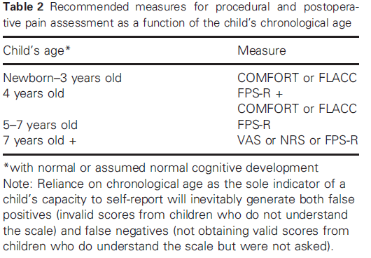

Self-report tools (5 years and above)

Postoperative pain

- Wong and Baker FACES Pain Scale : intended for 3–18 year olds.
- Faces Pain Scale-Revised* :intended for 4–12 year olds.
- Visual analogue* and numerical rating scales: intended for 8 years plus.
- Pieces of Hurt Tool* : intended for 3–8 year olds.

Observational/behavioral measures

Premature infants and neonates

Postoperative pain
- PIPP (Premature Infant Pain Profile)
- CRIES
- COMFORT

Children and young people without cognitive impairment

Postoperative pain (in the hospital setting)
- FLACC: intended for 1–18 year olds.

Children and young people with cognitive impairment

Postoperative pain
- NCCPC-PV (Non-Communicating Children’s Pain Checklist – Postoperative Version) : intended for 3–19 year olds.
- PPP (The Pediatric Pain Profile) : intended for 1–18 year olds.
- Revised FLACC : intended for 4–19 year olds.

AU-10 VALUSKAALADE SOOVITUS
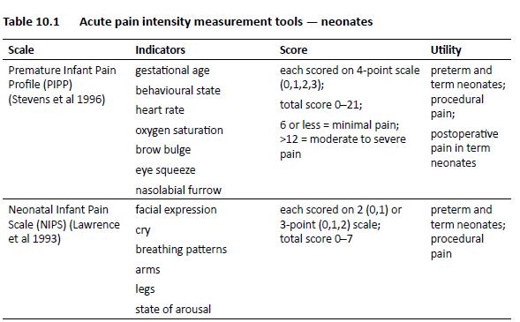
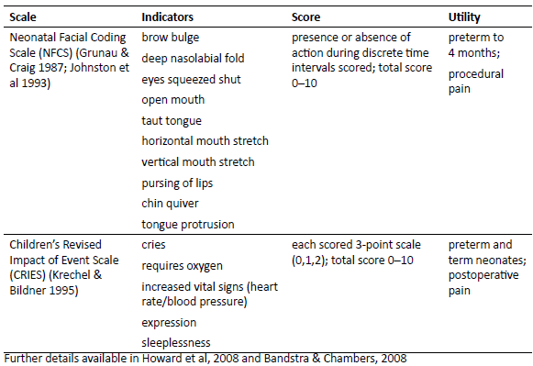

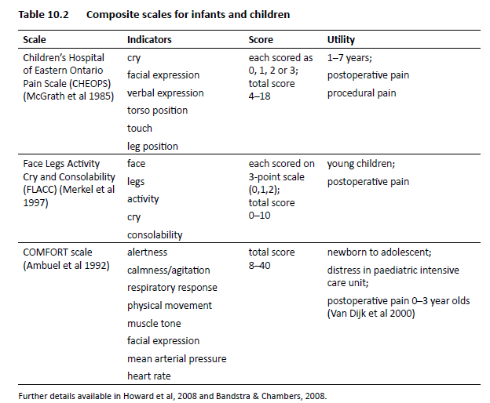

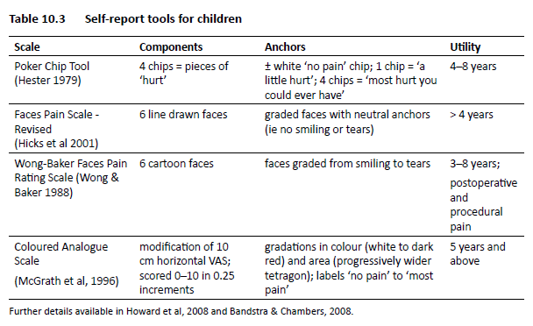

Valuskaalade süstemaatilised ülevaated ja muud uuringud
Kokkuvõte
Süstemaatilistes ülevaadetes rõhutatakse, et valu hindamine sobiva valuskaalaga peab olema regulaarne ja süstemaatiline, dokumenteeritud ning toimuma patsiendi kogu haiglasoleku vältel. von Baeyer jt. (2007) ning Stinson jt (2006) jõudsid järeldusele, et ei ole ühtset skaalat, millega oleks võimalik mõõta erinevas vanuses ja arenguetapis laste valu. Tomlinson jt. (2010) võrdlesid süstemaatilises ülevaates nelja „näo skaalat“ Faces Pain Scale (FPS) (skoor 0–6); Faces Pain Scale–Revised (FPS-R) (0 –10); Oucher pain scale (0 –10); ja Wong-Baker Faces Pain Rating Scale (WBFPRS) (0 –10). Leiti, et kõik neli skaalat olid piisavalt head, aga lapsed ise eelistasid WBFPRS, samas tõid uurijad välja, et selle puuduseks on nutvate nägude kasutamine skaalal, mis suurendab valu intensiivsust. Kliiniliseks kasutamiseks sobivad kõik eelnimetatud skaalad, kuid teaduslikeks uuringuteks soovitatakse FPS-R skaalat, selle psühhomeetriliste omaduste ja praktilisuse pärast.

Leidus mitmeid uuringuid, kus testiti/kasutati erinevaid valusakaalased laste postoperatiivse valu hindamiseks.

KÄITUMUSLIKUD SKAALAD (Behavioral tools)
PIPP Vederhus jt (2006) ja Jonsdottir jt. (2005) leidsid, et PIPP skaala osutus usaldusväärseks ja kehtivaks instrumendiks vastsündinute valu hindamisel. Skaala testimisel leidsid aga Srouji jt (2010), et PIPP on koormav ja aeganõudev erakorralises meditsiinis ning selle kasutamine intubeeritud vastsündinute puhul jääb küsitavaks.
CRIES McNair jt (2004) võrdlesid PIPP ja CRIES valuskaalasid vastsündinute postoperatiivse valu hindamisel. Uuringus osales 51 vastsündinut, kellel oli esimese elukuu jooksul olnud mingi operatsioon. Nad leidsid, et CRIES valuskaala on eelnevalt valideeritud, kui sobilik hindamise vahend ajaliste vastsündinute postoperatiivse valu hindamise jaoks ja PIPP skaala on kinnitatud sobilikuks enneaegsete ja ajaliste vastsündinute protseduuridest põhjustatud valu hindamiseks. Suraseranivongse1 jt (2006), võrdlesid kolme valideeritud skaalat (CRIES, NIPS, CHIPPS) ja leidsid, et nendest kolmest on NIPS skaala kõige parem vastsündinute postoperatiivse valu hindamiseks.

FLACC Ghai jt (2008) ning Manworren (2003) peavad FLACC skaalat usaldusväärseks ja kehtivaks mõõdikuks kahe kuu kuni 7-aastaste laste puhul. Ghai jt (2008) tõdevad, et see skaala on saanud tunnustust ka kognitiivselt kahjustatud laste postoperatiivse valu hindamisel.
COMFORT skaala on valiidne ja reliaabne mõõdik, hindamaks vastsündinute ja imikute (van Dijk) ning enneaegsete vastsündinute (Caljouw 2007) valu postoperatiivses perioodis.

SELF REPORT TOOLS
Huguet jt. (2010) uurimistulemustest selgub samuti, et kliinilises keskkonnas ja uurimistööde läbiviimiseks sobivad enesehindamise (self-report) skaalad Pieces of Hurt Tool, the Faces Pain Scale, the Oucher, või Visual Analogue Scales just nende praktilisuse pärast.

SÜSTEMAATILISED ÜLEVAATED

Tomlinson, D., et al. (2010) „A Systematic Review of Faces Scales for the Self-report of Pain Intensity in Children“ Pediatrics. 12: e1168–e1198

Context: Numerous faces scales have been developed for the measurement of pain intensity in children. It remains unclear whether any one of the faces scales is better for a particular purpose with regard to validity, reliability, feasibility, and preference.
Objectives: To summarize and systematically review faces pain scales most commonly used to obtain self-report of pain intensity in children for evaluation of reliability and validity and to compare the scales for preference and utility.
Methods: Five major electronic databases were systematically searched for studies that used a faces scale for the self-report measurement of pain intensity in children. Fourteen faces pain scales were identified, of which 4 have undergone extensive psychometric testing: Faces Pain Scale (FPS) (scored 0–6); Faces Pain Scale–Revised (FPS-R) (0 –10); Oucher pain scale (0 –10); and Wong-Baker Faces Pain Rating Scale (WBFPRS) (0 –10). These 4 scales were included in the review. Studies were classified by using psychometric criteria, including construct validity, reliability, and responsiveness, that were established a priori.
Results: From a total of 276 articles retrieved, 182 were screened for psychometric evaluation, and 127 were included. All 4 faces pain scales were found to be adequately supported by psychometric data. When given a choice between faces scales, children preferred the WBFPRS. Confounding of pain intensity with affect caused by use of smiling and crying anchor faces is a disadvantage of the WBFPRS.
Conclusions: For clinical use, we found no grounds to switch from 1 faces scale to another when 1 of the scales is in use. For research use, the FPS-R has been recommended on the basis of utility and psychometric features. Data are sparse for children below the age of 5 years, and future research should focus on simplified measures, instructions, and anchors for these younger children.

von Baeyer C, et al. (2007) „Systematic review of observational (behavioral) measures of pain for children and adolescents aged 3 to 18 years.“ Pain. 127: 140–150.

Abstract
Observational (behavioral) scales of pain for children aged 3 to 18 years were systematically reviewed to identify those recommended as outcome measures in clinical trials. This review was commissioned by the Pediatric Initiative on Methods, Measurement, and Pain Assessment in Clinical Trials (www.immpact.org). In an extensive literature search, 20 observational pain scales were identified for review including behavior checklists, behavior rating scales, and global rating scales. These scales varied in their reliance on time sampling and inclusion of physiological items, facial and postural items, as well as their inclusion of multiple dimensions of assessment (e.g., pain and distress). Each measure was evaluated based on its reported psychometric properties and clinical utility. Scales were judged to be indicated for use in specific acute pain contexts rather than for general use. Two scales were recommended for assessing pain intensity associated with medical procedures and other brief painful events. Two scales were recommended for post-operative pain assessment, one for use in hospital and the other at home. Another scale was recommended for use in critical care. Finally, two scales were recommended for assessing pain-related distress or fear. No observational measures were recommended for assessing chronic or recurrent pain because the overt behavioral signs of chronic pain tend to habituate or dissipate as time passes, making them difficult to observe reliably. In conclusion, no single observational measure is broadly recommended for pain assessment across all contexts. Directions for further research and scale development are offered.

Stinson, J.N., et al (2006). „Systematic review of the psychometric properties, interpretability and feasibility of self-report pain intensity measures for use in clinical trials in children and adolescents.“ Pain. 125(1-2):143-57

Abstract
The aim of this study was to systematically review the psychometric properties, interpretability and feasibility of self-report pain intensity measures for children and adolescents for use in clinical trials evaluating pain treatments. Databases were searched for self-report measures of single-item ratings of pain intensity for children aged 3-18 years. A total of 34 single-item self-report measures were found. The measures' psychometric properties, interpretability and feasibility, were evaluated independently by two investigators according to a set of psychometric criteria. Six single-item measures met the a priori criteria and were included in the final analysis. While these six scales were determined as psychometrically sound and show evidence of responsivity, they had varying degrees of interpretability and feasibility. No single scale was found to be optimal for use with all types of pain or across the developmental age span. Specific recommendations regarding the most psychometrically sound and feasible measures based on age/developmental level and type of pain are discussed. Future research is needed to strengthen the measurement of pain in clinical trials with children.

MUUD UURINGUD

Huguet, A., et al. (2010). „Measurement of self-reported pain intensity in children and adolescents“ Journal of Psychosomatic Research 68: 329–336

Acute and chronic pain is a common experience in children and youth. A thorough assessment is fundamental to understand this experience and to assess and monitor treatment responses.The intensity of pain is the parameter most commonly assessed. In this article, we describe the different methods employed to assess pediatric pain intensity and review well-validated and commonly used self-report measures of pain. This review is based on the recent systematic reviews conducted for the Pediatric Initiative on Methods, Measurement, and Pain Assessment in Clinical Trials Consensus Group and the Society of Pediatric Psychology. Amongst the several types of pediatric pain measures, self-report, when available, is regarded as the primary source of information about pain intensity, to be complemented by observation and knowledge of the context. There is a large number of self-report measures of pediatric pain intensity; and there is some agreement that professionals in the clinical and research practice should assess pain intensity using the Pieces of Hurt Tool, the Faces Pain Scale, the Oucher, or Visual Analogue Scales because these measures have shown to have sound psychometric properties and clinical utility. Despite the increased number of age-appropriate self-report measures of pediatric pain intensity over the last years, we report several research gaps and priorities of future research.

Bailey, B., et al (2007). „Comparison of Four Pain Scales in Children With Acute Abdominal Pain in a Pediatric Emergency Department“ Ann Emerg Med. 50:379-383.

Study objective: In children, the agreement between the many scales used to document the intensity of pain is not well known. Thus, to determine the agreement, we evaluate the visual analoog scale, the standardized color analog scale, the Wong-Baker FACES Pain Rating Scale, and a verbal numeric scale in children with acute abdominal pain suggestive of appendicitis in a pediatric emergency department (ED).
Methods: Participants were children who were aged 8 to 18 years, presented to a pediatric ED
with abdominal pain suggestive of appendicitis, and were recruited to participate in a randomized controlled trial evaluating the efficacy of morphine. Patients were initially asked to grade their pain on a plasticized color analog scale, a paper visual analog scale, a paper Wong- Baker FACES Pain Rating Scale, and then with a verbal numeric scale. Thirty minutes after morphine or placebo administration, the assessment was repeated. All scores were then
converted to a value of 0 to 100. Agreements between scores were evaluated with the Bland-
Altman method, and the 95% lower and upper limits were reported. We defined a priori the maximum limit of agreement at _20 mm.
Results: A total of 87 children were included in the study, 58 of them with confirmed appendicitis. The 95% limits of agreement for each pair of scales were visual analog scale/color analog scale _18.6, 14.4; visual analog scale/Wong-Baker FACES Pain Rating Scale _20.1, 33.7; visual analoog scale/verbal numeric scale _30.2, 20.7; color analog scale/Wong-Baker FACES Pain Rating Scale _18.5, 36.3; color analog scale/verbal numeric scale _26.9, 22.1; and Wong-Baker FACES Pain Rating Scale/verbal numeric scale _38.7, 15.7.
Conclusion: Our study suggests that only the visual analog scale and the color analog scale have acceptable agreement in children with moderate to severe acute abdominal pain. In particular, the verbal numeric scale is not in agreement with the other evaluated scales.

von Baeyer, C. L., (2006). „Children’s self-reports of pain intensity: Scale selection, limitations and interpretation“ Pain Res. Manage 3:157-162

Most children aged five years and older can provide meaningful selfreports of pain intensity if they are provided with age-appropriate tools and training. Self-reports of pain intensity are an oversimplification of the complexity of the experience of pain, but one that is necessary to evaluate and titrate pain-relieving treatments. There are many sources of bias and error in self-reports of pain, so ratings need to be interpreted in light of information from other sources such as direct observation of behaviour, knowledge of the circumstances of the pain and parents’ reports. The pain intensity scales most commonly used with children – faces scales, numerical rating scales, visual analogue scales and others – are briefly introduced. The selection, limitations and interpretation of self-report scales are discussed

Srouji, R., et al. (2010). Pain in Children: Assessment and Nonpharmacological Management. International Journal of Pediatrics.

Pain perception in children is complex, and is often difficult to assess. In addition, pain management in children is not always optimized in various healthcare settings, including emergency departments. A review of pain assessment scales that can be used in children across all ages, and a discussion of the importance of pain in control and distraction techniques during painful procedures are presented. Age specific nonpharmacological interventions used to manage pain in children are most effective when adapted to the developmental level of the child. Distraction techniques are often provided by nurses, parents or child life specialists and help in pain alleviation during procedures.

FPS

Hunter, M., et al. (2000). „An Evaluation of the Faces Pain Scale with Young Children“ J Pain Symptom Manage. 20:122–129.

Abstract
The psychometric characteristics of the Faces Pain Scale (FPS) were evaluated in three groups
of preschool and school-aged children (3.5–4.5; 4.5–5.5 and 5.5–6.5 years, respectively). The
FPS was adequately comprehended by even young children. It was easily administered and was valid and discriminating. It did not, however, possess the linear scalability claimed by its
authors.

COLOUR ANALOG SCALE

McConahay, M., et al (2007). „Clinically significant changes in acute pain in a pediatric
ED using the Color Analog Scale“ American Journal of Emergency Medicine. 25: 739–742

Objective: The purpose of this study is to quantify, using the Color Analog Scale (CAS), the degree of change in pain severity required to achieve a clinically significant improvement in pain.
Methods: A prospective descriptive study, using convenience sampling of children aged 5 and 12 years presenting to a pediatric emergency department (ED) with acute pain, was done. Children were asked to mark their pain severity on a previously validated CAS. After a pain intervention, the child was again asked to mark their pain intensity on the CAS and asked to describe the relative change in their pain. The main outcome measure was to quantify the smallest change required for the child to state that their pain was improved.
Results: One hundred twenty-six children with a mean age of 8.6 years (SD, 2.8 years) were enrolled. Males accounted for 56%. Pain was traumatic in 47.6% and nontraumatic in 52.4%. Of the 126 pain comparisons made, 28 children described their pain as bthe same Q and had a mean change in score of _0.10 cm (95% confidence interval [CI], _2.27 to 2.07 cm). Pain was judged to be a blittle lessQ in 58 children, and the CAS score changed by a mean of _2.4 cm (95% CI, _3.15 to _1.72 cm). In the 29 children who judged their pain to be bmuch less,Q the CAS score decreased by a mean of _5.4 cm (95% CI, _6.50 to _4.40).
Conclusion: A decrease on the CAS pain scale of 2.4 cm (95% CI, 2.95–1.92) is a clinically significant change in pain for children aged 5 to 12 years with acute pain. The CAS is a valuable tool in assessing responses to pain interventions.

PIPP
l Practice1356-1294
Vederhus BJ. et al. (2006) „Psychometric testing of a Norwegian version of the Premature Infant Pain Profile: an acute pain assessment tool. A clinical validation study.“ Int J Nurs Pract. 6:334-44.

As neonates are submitted to pain, assessing the pain is crucial in effective pain control. The Premature Infant Pain Profile, an acute measurement tool combining physiological, behavioural and contextual indicators, was translated into Norwegian and tested clinically. The purpose was to establish construct validity, interrater reliability and internal consistency. In addition, the effect of sucrose as pain analgesia was tested in neonates >or= 36 weeks of gestational age. In a known-groups comparisons design with repeated measures, 111 consecutive neonates, preterm and term, were all observed at baseline, non-pain and pain event. Neonates in the neonatal unit received sucrose at pain event. A significant interaction effect of gestational age and events was found in the sucrose neonates. A significant interaction effect was detected from sucrose and event type for neonates from 36 weeks. The internal consistency of the six-item score was acceptable. A correlation coefficient of 0.89-0.97 was obtained for interrater reliability. The Norwegian version of the Premature Infant Pain Profile seems to be a reliable and valid instrument for pain assessment in neonates.
6598605
Jonsdottir, R.B., et al. (2005). „The sensitivity of the premature infant pain profile – PIPP to measure pain in hospitalized neonates.“ Journal of Evaluation in Clinical Practice, 11 , 6: 598–605

Aim The present study uses an Icelandic translation of the original versioon of the Premature Infant Pain Profile (PIPP) in order to assess its accuracy and sensitivity to the measure of pain in hospitalized neonates in Iceland. The PIPP is a composite tool developed to assess acute pain in preterm and term neonates.
Methods. A crossover design, with a sample of 24 neonates, was used on three, routinely occurring events in the neonatal intensive care unit, where neonates were their own controls. The three events were baseline, non-pain and pain event. Neonates were independently assessed for their pain, using the Icelandic translation of the PIPP, at the bedside.
Results. Repeated measures analysis yielded a statistically significant main effect for the three events (pain, non-pain and baseline), thus differentiating pain from non-pain and baseline events (F= 57.11; P< 0.0001). Pairwise comparisons were subsequently carried out and the results show that PIPP scores at the pain event (11.72) were significantly lower (P< 0.0001) than that at the non-pain event (6.04) and that at the baseline event (3.54; P < 0.0001). The PIPP scores at the non-pain event were also significantly higher than that at the baseline event ( P< 0.0001). These results suggest that the PIPP measure is sensitive to a painful event and differentiates between stress and pain in a clinical context across linguistic barriers. The findings also revealed almost a complete correlation between the PIPP scores of the two independent nurse raters at all events ( P < 0.0001).
Conclusion. Therefore the authors conclude that the Icelandic translation of the PIPP qualifies as a satisfying measure of pain responses in Icelandic neonates and can be recommended for use by clinicians and researchers. More research is, however, needed to further the accuracy and validity of the PIPP measure in general to assess pain in neonates in comparison to other pain measures.

CRIES

Suraseranivongse1, S., et al (2006). „ A comparison of postoperative pain scales in neonates“ British Journal of Anaesthesia 97 (4): 540–4 (2006)

Background. Practical, valid and reliable pain measuring tools in neonates are required in clinical practice for effective pain management and prevention of the evaluator bias.
Methods. This prospective study was designed to cross-validate three pain scales: CRIES (cry, requires O2, increased vital signs, expression, sleeplessness), CHIPPS (children’s and infants’ postoperative pain scale) and NIPS (neonatal infant pain scale) in terms of validity, reliability and practicality. The pain scales were translated. Concurrent validity, predictive validity and interrater reliability in postoperative pain were studied in 22 neonates after major surgery. Construct validity and concurrent validity in procedural pain were determined in 24 neonates before and during frenulectomy under topical anaesthesia.
Results. All scales had excellent interrater reliability (intraclass correlation >0.9). Construct validity was determined for all pain scales by the ability to differentiate the group with low pain scores before surgery and high scores during surgery (P<0.001). The positive correlations among all scales, ranging between r=0.30 and r=0.91, supported concurrent validity. CRIES showed the lowest correlation with other scales with correlation coefficients of r=0.30 and r=0.35. All scales yielded very good agreement (K>0.9) with routine decisions to treat postoperative pain. High sensitivity and specificity (>90%) for postoperative pain from all scales were achieved with the same cut-off point of 4. In terms of practicality, NIPS was the most acceptable (65%).
Conclusions. Based on our findings, we recommended NIPS as a valid, reliable and practical tool.

CRIES ja PIPP

McNair, C., et al (2004).“Postoperative pain assessment in the neonatal intensive care unit“Arch Dis Child Fetal Neonatal Ed;89:F537–F541

Objectives: To compare the convergent validity of two measures of pain (premature infant pain profile (PIPP) and crying, requires oxygen, increased vital signs, expression, and sleepless (CRIES)) in real life postoperative pain assessment in infants.
Methods: This study was a prospective, repeated measures, correlational design. Two staff nurses were randomly assigned either the PIPP or CRIES measure. An expert rater assessed each infant after surgery, and once a day using the visual analogue scale (VAS).
Setting: A level III neonatal intensive care unit in a metropolitan university affiliated paediatric hospital.
Results: Pain was assessed in 51 neonates (28–42 weeks of gestational age) after surgery. There was no significant difference in the rates of change between the pain assessment measures across time using repeated measures analysis of variance (F50,2 = 0.62, p = 0.540), indicating correlation between the measures. Convergent validity analysis using intraclass correlation showed correlation, most evident in the first 24 hours (immediately, 4, 8, 20, and 24 hours after the operation). Correlations were more divergent at 40 and 72 hours after surgery. No significant interactions were found between gestational age and measure (F304,4 = 0.75, p = 0.563) and surgical group and measure (F304,2 = 0.39, p = 0.680).
Conclusions: PIPP and CRIES are valid measures that correlate with pain for the first 72 hours after surgery in term and preterm infants. Both measures would provide healthcare professionals with an objective.

COMFORT

Caljouw, M.A.A., et al. (2007). „Measurement of pain in premature infants with a gestational age between 28 to 37 weeks: Validation of the adapted COMFORT scale“. Journal of Neonatal Nursing 13: 13-18

Abstract
The aim of our study was to test the reliability and validity of the adapted COMFORT scale in premature infants with a gestational age between 28 to 37 weeks using the VAS as comparison. Two nurses made paired observations before and after the heel puncture for routine neonatal metabolic screening. They completed the adapted COMFORT scale and VAS for 57 premature infants, dividend into five gestational age groups. The interrater reliability for the COMFORT scale, given by a linearly weighted kappa ranged from 0.62 to 0.84. The intraclass coefficient for the total COMFORT score was 0.85 (95% CI 0.76e0.91) in the pre-test and 0.93 (95% CI 0.89e0.96) in the post-test. The items of the COMFORT scale had a high internal consistency. No significant differences in distress and pain in the various
gestational age subgroups were observed. The adapted COMFORT scale is a valid and reliable instrument to measure distress and pain in premature infants.

van Dijk, M., (2000). “The reliability and validity of the COMFORT scale as a postoperative pain instrument in 0 to 3-year-old infants.“ Pain 84(2-3):367-77.
The aim of this study was to test the reliability and validity of the COMFORT scale as a postoperative pain instrument for children aged 0-3 years. Subjects were 158 neonates and toddlers after major abdominal or thoracic surgery. Trained nurses rated the children's pain at 3, 6 and 9 h postoperative on the Pediatric Surgical Intensive Care Unit using the COMFORT and a VAS for pain. Interrater reliability of the COMFORT items proved to be good (Kappa 0.63-0.93) for all items with the exception of the item 'Respiratory response', which was moderate (Kappa 0.54). LISREL analyses showed that the structure of the COMFORT data was best represented by three latent variables: COMFORT 'behaviour' with loadings from the behavioural items (Alertness, Calmness, Respiratory response/Crying, Physical movement, Muscle tone and Facial tension) and separate latent variables for 'Heart rate baseline' (HR) and 'Mean arterial blood pressure baseline' (MAP). Factor loadings of the items were invariant across time, indicating stability of the structure. The latent variables COMFORT 'behaviour' and VAS pain were highly interrelated indicating congruent validity. Stability of COMFORT 'behaviour' and VAS pain was moderate which might be due to varying painful episodes in this sample. HR and MAP, although stable across time, were weakly related to VAS pain and COMFORT 'behaviour'. These findings support the use of the COMFORT 'behaviour' scale to assess postoperative pain in neonates and infants.

FLACC

Ghai, B., et al. (2008). Postoperative pain assessment in preverbal children and children with cognitive impairment. Pediatric Anesthesia, 18: 462-477.

Postoperative pain assessment and management in preverbal children and children with cognitive impairment poses major challenges to pediatric anesthesiologists. An accurate diagnosis of extent of pain is the keystone for the successful management of pain. This article
reviews the neurobiology of pain at birth, long-term consequences of early pain and different pediatric pain assessment tools used for postoperative assessment in infants, young children, and children.

Manworren, R.C.B, et al. (2003) „Clinical validationof FLACC: preverbal patient pain scale.“ Pediatr Nurs 2003; 29: 140–146.

Purpose: To test the validity of the Faces, Legs, Activity, Cry and Consolability (FLACC) pain assessment tool by measuring changes in scores in response to analgesics.

Methods: Pediatric nurses used the FLACC scale to assess pain in 147 children under 3 years of age who were hospitalized in the pediatric intensive care unit (PICU), post-anesthesia care unit (PACU), surgical/trauma unit, hematology/oncology unit, or infant unit. FLACC is an observational tool for quantifying pain behaviors. Facial expression, leg movement, activity, cry, and consolability are each scored 0-2, for a total FLACC score of 0-10. The FLACC measurements were done pre-analgesia, at predicted onset of analgesia, and at predicted peak analgesia.

Findings: Pre-analgesia FLACC scores were significantly higher than post-analgesic scores and significantly higher for patients who received opioids than patients who received non-opioids. Peak analgesia FLACC scores across analgesia groups were not significantly different and reflect effective pain relief for patients regardless of analgesic choice.

Conclusions: The FLACC pain assessment tool is appropriate for preverbal children in pain from surgery, trauma, cancer, or other disease processes. The results support pediatric nurses' clinical judgment to determine analgesic choice rather than providing distinct FLACC scores to guide analgesic selection.

Laste skaalade tabelid

Vanus |  | Skaalad
Enneaegsed ja ajalised vastsündinud |  | Käitumuslikud skaalad | PIPP, CRIES, COMFORT
Imikud ja kuni 3 aastased |  | Käitumuslikud skaalad | FLACC, COMFORT
Lapsed üle 3 aasta: |  | Enesehindamise skaalad
 | 3-12 |  | FACES, FPS-R
 | Kuni 18 |  | FACES
 | > 8 |  | VAS , NRS

SKAALA | Lapse vanus | Indikaator | Kirjandus
PIPP  Premature Infant Pain Profile  Käitumuslik mõõdik | Enneaegsed vastsündinud,  Vastsündinud ja imikud.  (PEDI-12; AU-10) | Gestatsioonivanus  Käitumine  Südamelöögisagedus  Saturatisoon  Kulmukortsutus? Brow bulge?  Silmade kissitamine  Ninasuu kolmnurk (vagu?)  0-21 punkti ( Hinnatakse 4-punkti skaalal 0;1;2;3)  6 või vähem punkti= minimaalne valu  >12= mõõdukas kuni äge valu | PIPP skaala on usaldusväärne instrument vastsündinute valu hindamisel (Vederhus jt.2006; Jonsdottir jt. 2005). McNair jt (2004) ütlevad, et PIPP skaala on sobilik enneaegsete ja ajaliste vastsündinute protseduuridest põhjustatud valu hindamiseks. Srouji jt (2010) leidsid, et PIPP on koormav ja aeganõudev ning selle kasutamine intubeeritud vastsündinute puhul jääb küsitavaks.
CRIES  Käitumuslik mõõdik | Enneaegsed ja ajalised vastsündinud  (PEDI-12; AU-10) | Nutt  Hapniku vajadus  Elulised näitajad (südamelöögisagedus, vererõhk)  Näoilme  Unetus  Skoor 0-10 punkti ( Hinnatakse 3-punkti skaalal 0;1;2) | CRIES valuskaala on sobilik hindamise vahend ajaliste vastsündinute postoperatiivse valu hindamiseks. (McNair jt. 2004)
COMFORT  Käitumuslik mõõdik | Enneaegsed vastsündinud. Vastsündinud ja lapsed kuni 3 aastased. (PEDI-12; AU-10) | Erksus  Rahulikkus/ärevus  Hingamissagedus  Liigutused  Lihastoonus  Näoilme  Keskmine arteriaalne rõhk  Pulsisagedus  8-40punkti | Skaala sobib hindamaks vastsündinute ja imikute (van Dijket jt 2000) ning enneaegsete vastsündinute (Caljouw 2007)postoperatiivset valu.
FLACC  Face Legs Activity Cry and Consolability  Käitumuslik mõõdik | 1-18 lapsed (PEDI-12)  Noored lapsed (Young children?) (AU-10) | Nägu  Jalad  Aktiivsus  Nutt  Lohutatavu  0-10 punkti. | Ghai jt (2008) ning Manworren (2003) peavad FLACC skaalat usaldusväärseks ja kehtivaks mõõdikuks kahe kuu kuni 7-aastaste laste puhul. Ghai jt (2008) tõdevad, et see skaala on saanud tunnustust ka kognitiivselt kahjustatud laste postoperatiivse valu hindamisel.
FPS  Faces Pain Scale  Enesehindamisskaala | 3-18 aastat (PEDI_12)  Üle 4 aasta (AU-10) | Skoor 0–6 punkti | Kliiniliseks kasutamiseks sobivad „näo skaaladest“ nii Faces Pain Scale (FPS) Faces Pain Scale–Revised (FPS-R) Oucher pain scale; ja Wong-Baker Faces Pain Rating Scale (WBFPRS). Teadusuuringuteks soovitatakse FPS-R skaalat, selle psühhomeetriliste omaduste ja praktilisuse pärast. (Tomlinson jt. 2010).  Huguet jt. (2010) uurimistulemustest selgub samuti, et kliinilises keskkonnas ja uurimistööde läbiviimiseks sobivad enesehindamise skaalad Pieces of Hurt Tool, the Faces Pain Scale, the Oucher, või Visual Analogue Scales just nende praktilisuse pärast. Ka Hunter, M., et al. (2000) leidsid, et FPS skaala on lihtsasti kasutatav ja sobilik postoperatiivse valu mõõtmiseks  Bailey, B., et al (2007) leidsid, et mõõduka ja tugeva kõhuvalu mõõtmiseks lastel sobib VAS ja värviskaala ning NRS ei ole kooskõlas teiste hinnatud skaaladega.
FPS-R  Faces Pain  Scale-  Revised  Enesehindamisskaala | Alates 4 eluaastast (PEDI-12; AU-10) | skoor 0 –10 punkti
VAS  Visual Analogue Scale  Enesehindamisskaala | alates 8 eluaastast (PEDI-12; WHO) | Skoor 0-10 punkti
NRS  Numerical Rating Scale  Enesehindamisskaala | alates 8 eluaastast (PEDI-12; WHO) | skoor 0 –10 punkti

