Tervishoiukorralduslikud küsimused

Missugused spetsialistid peaksid kuuluma perioperatiivse ägeda valu ravi meeskonda ning millised peaksid olema nende ülesanded?
Background
Postoperative pain has been poorly treated in hospitals for years (Powell, Davies, Bannister, & Macrae, 2009). There are many effective pharmacological and other treatments, many of them relatively low cost, but delivering these treatments to all surgical patients is dependent on co-ordinated multi-professional working (Powell et al. 2012).
In some hospitals the acute pain service (APS) continues to be primarily for managing postoperative pain and supervising electronic equipment that delivers pain relief. For others the role of the APS has been extended to provide a more comprehensive service dealing with complex patients (opioid-tolerant patients), older patients, acute cancer pain and pain resulting from acute medical conditions such as pancreatitis and sickle cell disease.
The structure of the acute pain team can vary from a ‘low-cost’ service that is nurse-based and anaesthetist-led (but without daily participation by an anaesthetist), to an anaesthesiacentred one, with daily input by an anaesthetist and APS nurse and 24-hour cover by anaesthetists. Additionally, clinical input from pharmacists is occurring increasingly. There is no consensus as to the best model for an APS and it has been suggested that tailoring the service to the local environment/needs may be as important as choice of analgesic modalities. (Jack and Baggott. "Control of acute pain in postoperative and post-traumatic situations and the role of the acute pain service."Anaesthesia & Intensive Care Medicine 12.1 (2011): 1-4.)

Ravijuhendid

Kokkuvõte:
Ravijuhendid AU-10 ja DE-07 ei anna otsest soovitust, millised spetsialistid peaksid kuuluma perioperatiivse ägeda valu ravi meeskonda. Meeskond peaks soovitavalt olema multidistsiplinaarne ja selle koosseis tulenema kohalikest oludest ning ressurssidest. Ägeda valu ravi meeskonna töö võib olla nii arsti poolt juhitav kui ka peamiselt õdede tööl põhinev.
1.“ Behandlung acuter perioperativer und postraumatischer Schmertzen” 2009 (DE-07)
Ägeda valuravi meeskonna juurutamine tervishoiuasutuses tasub ennast ära. GoR: B
Olemasolevatest ressurssidest ja kohalikest oludest sõltuv õdede tööl põhinev valuravimeeskond (arsti järelvalve all) on alternatiiviks anestesioloogi tööl põhinevale valumeeskonnale (Bernd et al., 2004; Rawal, 2005). Sellisel juhul saab eriväljaõppega õenduspersonal suurema vastutuse võtta. Adekvaatse valuravi korraldamiseks on hädavajalik luua tugev ja stressi taluv organisatsioonivorm.

- Acute Pain Management: Scientific Evidence 2010 (AU10)

There is a wide diversity of APS structures, no consensus as to the best model, and no agreed definition of what might consitute such a service (Counsell et al. 2008).
Some are “low-cost” nurse-based (Shapiro et al. 2004; Rawal 2005), others are anesthetist-led but rely primarily on APS nurses as there may not be daily clinical participation by an anesthetist (Harmer 2001, Nagi 2004) and some are comprehensive and multidisciplinary services with APS nursing staff, sometimes pharmacist or other staff, and daily clinical input from, and 24-hour cover by, anesthetists (Ready et al 1988; Mcintyre et al. 1990; Schug and Haridas 1993).

- American Pain Society “ Interdisciplinary Pain Management” guideline 2010

Table 2. Members of the Interdisciplinary Pain Team
• Patient
• Family
• Physicians (e.g., physiatrist, anesthesiologist, addictionologist)
• Nurses
• Psychologists
• Physical therapists
• Occupational therapists
• Recreational therapists
• Vocational counselors
• Pharmacists
• Nutritionists / dieticians
• Social workers
• Support staff
• Volunteers

Süstemaatilised ülevaated
Kokkuvõte süstemaatilistest ülevaadetest: Leidus üks süstemaatiline kirjanduse ülevaade, milles vaadeldud uuringutes oli valuravimeeskond peamiselt arstide tööl põhinev.

- Werner et al. "Does an acute pain service improve postoperative outcome?" Anesthesia & Analgesia 95.5 (2002): 1361-1372.

Aim: to critically review the literature on APSs regarding outcome: pain relief, side effects of the postoperative pain treatment, patient satisfaction, therapy-related adverse events, morbidity, hospital stay, and cost issues.
Method: Literature was identified by a MEDLINE search from March 1966 to February 2001.
Results: 154 papers were retrieved and systematically evaluated, 58 were classified as expert opinions (editorials or personal experience), 48 as audits, 18 as general reviews (pain, organization, and pain-relief methods), 17 as surveys (regional, national, and international), and 13 as clinical trials.
In 73 of the reviewed articles relating to organizational aspects of the APS, 15 articles reported a multidisciplinary approach (physician, nurse, physiotherapist, pharmacist, or psychologist), whereas in 56, the service was strictly physician based and in 17, strictly nurse based. It has automatically been assumed that the APS should be under anesthesiological auspices (11,15,31), but services managed primarily by ward surgeons have been reported (33,46).

Muud artiklid:

Kokkuvõte:
Leitud artiklitest selgus, et ägeda valu ravi meeskond peaks olema multidistsplinaarne. Kindlat struktuuri, kes valu ravi meeskonda peaksid kuuluma ei ole, sest riigiti on see erinev. Kõige sagedamini kuuluvad perioperatiivse ägeda valu ravi meeskonda anestesioloogid, õed kes on saanud spetsiaalse väljaõppe ning proviisorid. Harvem kuuluvad meeskonda füsioterapeut, psühholoog ning kirurg. American Pain Society juhend (2010) lisab meeskonda ka patsiendi ja tema perekonna. Valuravi meeskonna töö võib olla peamiselt arstide juhitud kui ka õdedel põhinev (arsti järelvalve all).
Ägeda valu ravimeeskonna ülesanded: regulaarne patsiendi jälgimine, valu ja valuvaigistite mõju hindamine ning dokumenteerimine, valutustamise korraldamine, jälgimine ning dokumenteerimine, kvaliteetse valuravi tagamine, patsiendi ja teiste meditsiinitöötajate õpetamine ning valuga seotud uurimistöö. Kitowski, et al (2002) on kirjeldanud põhjalikult ägeda valu ravi õe spetsiifilisi ülesandeid.

- Boekel et al. "Acute Pain Services and Postsurgical Pain Management in the Netherlands: A Survey." Pain Practice (2014).

Aim: to investigate the existence, structure, and responsibilities of Dutch acute pain services (APSs).
Method: Survey. Information gathered by a digital questionnaire, sent to all 96 Dutch hospitals performing surgical procedures.
Results: Completed questionnaires were received from 80 hospitals (83%), of which 90% have an APS. Important duties of the APS are regular patient rounds, checking complex pain techniques (100%), supporting quality improvement of pain management (87%), pain education (100%), and pain research (21%).
Organization of APS: Almost all hospitals indicate that the responsibility for the APS is within the department of anesthesiology (including pain clinics). The median number full time equivalents (FTE) of APS members is 3.3 with a range of 0.5 to 36.0 FTE. Most team members are nurses, of which some are specialized in the treatment of pain. In the majority of APS teams, an anesthesiologist is the responsible supervisor; other reported supervisors are a nurse practitioner or a nurse pain specialist.

- Nielsen et al. "Post‐operative pain treatment in Denmark from 2000 to 2009: a nationwide sequential survey on organizational aspects." Acta Anaesth Scand 56.6 (2012): 686-694.

Aim: to study the association between the developments of post-operative pain management and the accelerated post-operative rehabilitation programmes (ACC) by sequential analyses from 2000 to 2009.
Methods: In 2000, 2003, 2006 and 2009, a questionnaire was mailed to all Danish anaesthesiology departments. The headings of the questionnaire were demographics of responder departments, resources allocated to pain management methods, quality
assessment methods, research activities and implementation of ACC.
Results: The responder rates varied between 80% and 94% (mean 88%) representing a mean number of anaesthetics of 340.000 per year. The number of APSs in the study period varied in university hospitals between 52% and 71% (P = 0.01), regional
hospitals between 8% and 40% (P < 0.01), and local hospitals between 0% and 47% (P < 0.01).
Conclusions: The study, spanning nearly a decade, illustrates that following an increase in number of APSs from 2000 to 2006, followed by a significant decline, a steadily increasing number of departments implemented ACC.

- Jack and Baggott. "Control of acute pain in postoperative and post-traumatic situations and the role of the acute pain service." Anaesth Int Care Medicine 12.1 (2011): 1-4.

Table 1.
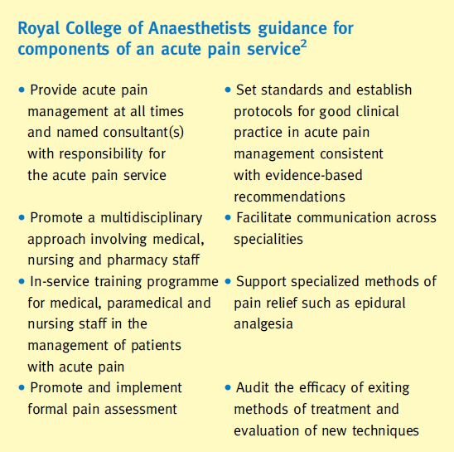

Rawal, N. (2005). "Organization, function, and implementation of acute pain service." Anesthesiol Clin North America 23(1): 211-25.

Abstract
Undertreatment of postoperative pain continues to be a major problem internationally. The solution does not seem to be the development of new analgesic drugs or technologies but the development of an appropriate organization that utilizes existing expertise. Evidence suggests that the introduction of an Acute Pain Service (APS) reduces patients' pain intensity, but other outcome benefits are modest. Although the number of hospitals with an APS is increasing, the literature is unclear about the optimal structure, staffing, and function. There is a need for the development of well-defined APS criteria with which to assess performance and compare with national standards.

- Nagi, H. "Acute pain services in the United Kingdom." Acute Pain 5.3 (2004): 89-107.

Aim: To address the structure and function of the acute pain services (APS) in the UK 10 years after its initial commencement.
Method: non-experimental, descriptive, cross-sectional survey. The approach of this survey was based on a cohort, which comprised all hospitals with college tutors of the Royal College of Anaesthetists. This group is believed to reflect the management of acute pain services across the country.
Resuts: A total of 282 questionnaires were mailed to the anaesthetic college tutors in 282 different hospitals. Total response rate was 80.4%. APS were available in 89.4% of the total number of hospitals that responded. All the data were for the period of 1 year 1999.
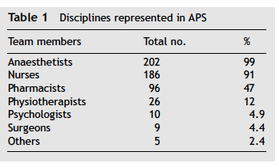

- Warren Stomberg and Haljamäe. Acute pain services. Current Anaesthesia & Critical Care (2003) 14, 211-215

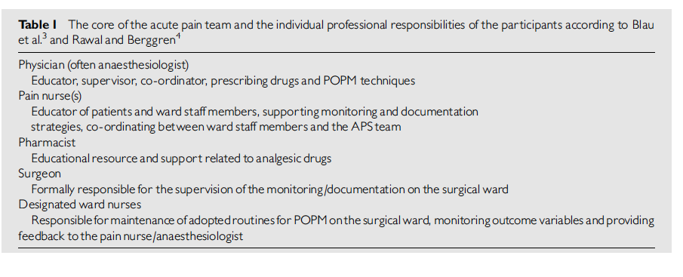

- Kitowski and McNeil. "Evaluation of an acute pain service." J Peri Anesth Nursing 17.1 (2002): 21-29.

Table 2. Description of the Role of the Acute Pain Service Nurse

Purpose of Role: The APS nurse works with the APS team and RNs throughout the HHSC to support acute pain management for patients on the acute pain service.
Specific Responsibilities:
- Participates in daily clinical rounds with the APS anesthesiologist for all patients in the APS.
- PCA Daily Rounds
- Obtain charts, review patients’ diagnosis, surgical procedure, nurses notes, physician orders
- Patient assessment—evaluate pain, both at rest and with activity; worst pain and least pain in 24 hours
- Review dose of analgesic medication given in past 24-hour parameters of PCA settings (bolus, lockout interval, continuous infusion, 4-hour limit)
- Determine whether side effects present
- Review vital signs
- Note whether patient able to take fluids by mouth when first flatus, first bowel movement
- Note when first sitting and first walking
- Evaluate patients’ overall satisfaction with pump
- Discuss assessment findings with patients’ nurse
- Document findings and plan in patients’ chart
- Epidural Daily Rounds
- Obtain chart, review patients’ diagnosis, surgical procedure, nurses notes, physician orders
- Patient assessment—evaluate pain, both at rest and with activity; worst and least pain in 24 hours
- Assess epidural site
- Review the dose of analgesic medication given in the past 24 hours and present parameters of bolus administration or infusion pump settings
- Determine whether side effects present, use all assessment scales including motor and sensory
- Review vital signs
- Note when first sitting and ability to ambulate
- Note whether patient able to take po fluids when passing flatus, first bowel movement
- Evaluate patients’ overall satisfaction with pain treatment
- Discuss assessment findings with patients’ nurse
- Document findings and plan in patients’ chart

General Responsibilities:
- The APS nurse will work with the anesthesiologist on the APS team.
- Supports patient and family education regarding pain management (PCA or epidural) postoperatively in collaboration with the patient’s nurse.
- Provides education, both formal and informal to RNs throughout the HHSC on APS treatments and policies. Keeps staff updated on new developments and trends in pain management.
- Identifies and assists in problem-solving issues related to pain management and discusses with appropriate staff and/or intervenes.
- Provides technical support to staff and physicians for troubleshooting equipment problems with the PCA pump and the epidural pump.
- Participates in monitoring pain management outcomes.
- Collects data for ongoing evaluation of APS with a focus on patient outcomes including patient satisfaction, side effects and efficacy of pain treatments
- Participates in ongoing education and research for the APS nurse role (ie, workshops, Internet resources, etc).

